Дата: 09.02.2023 Клас: 6-А

Предмет : Англійська мова

Тема: Магазини та гроші.

Мета: формувати навички вживання нових лексичних одиниць з тем «Магазини та кафе»; удосконалювати навички аудіювання й усного мовлення з опорою на лексико-граматичні структури; розвивати мовну здогадку; виховувати доброзичливе ставлення до співрозмовника.

Вчитель: Глуговська Л.Г.

**Хід уроку**

***1.Greeting***

Good afternoon, dear children! I’m glad to see you. Are you ready to start our lesson? Let’s start.

Pupils, the subject of our today’s lesson is “Shopping in Britain”.

***2. Listening***

*Watch the video about «This is Britain Food»*

*Перегляньте відео та пригадайте назви різних типів їжі.*

[***https://www.youtube.com/watch?v=aKbIilKwJwg***](https://www.youtube.com/watch?v=aKbIilKwJwg)

***3. Warming up / Vocabulary practice***

Now let’s play the game “Magic box”. I’ve got a magic box. You should take a card from it, read the message and guess what shop is this.

**Game «Magic box».**

*1. I can buy some milk at this shop.*

*2. They sell bananas at this shop.*

*3. Where can I buy some bread?*

*4. Where do they sell newspapers?*

*5. They sell meat at this shop.*

*6. Where can I buy some eggs?*

*7. Where can I buy some toothpaste?*

*8. I can buy an interesting book at this shop.*

*9. I can buy a nice doll at this shop.*

*10. I’d like two loaves of bread and a cake!*

*11. Can I try this pair of jeans on?*

*12. How much do two kilos of sausages cost?*

*13. I want to buy a teddy bear for my little brother.*

***4. Speaking***

**T:** Match the words with their definitions.

|  |  |
| --- | --- |
| 1) dairy  2) grocery  3) butcher’s  4) greengrocery  5) a customer  6) goods  7) a shop assistant | a) a shop where meat is bought  b) things that are sold and bought  c) a person who comes into a shop to buy something  d) a woman or a man serving in a shop  e) a shop where oil or eggs are bought  f) a shop where milk, cheese or sour cream are bought  g) a shop where they sell fruit or vegetables |

***5. Reading***

Read to the text and name the shops that are in the street where John lives.

**In my street**

I am John. Let me tell you about my street. It is not very long. There are some shops in the street and a lot of trees. There is a baker’s shop with fresh bread and a greengrocer’s with fresh fruit and vegetables. I go to the supermarket every day.

It is next to my house. It is not a busy street so we ride our bikes there. Some boys play ball in the street, but it is dangerous. There are no tall buildings there, just family houses and small blocks of flats. There are a lot of cats in my street.

I have some nice neighbours. I love my street very much.

I want to give you some advises if you are going to do the shopping in the UK.

* *If you don’t know something about doing shopping, you may ask a shop assistant to help you.*
* *Do not put any item in your bag or pocket until you have paid for it. Use basket or trolley if they are provided.*
* *Always keep the receipt after shopping.*
* *Mind that size system in Britain is different from European one.*

***6. Grammar***

some/any

**Some** вживається в стверджувальних реченнях

**any –** в заперечних та питальних реченнях.

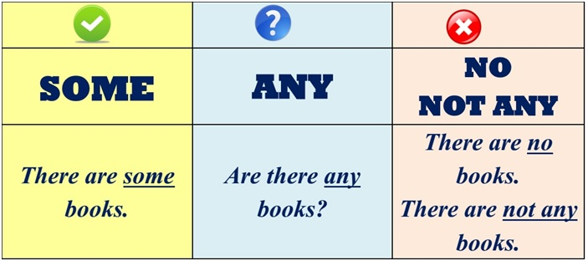

***7. Writing***

***Thursday, the ninth of February***

***Classwork***

Рut the necessary pronoun.

Доповніть речення потрібним займенником some/any.

1. There is …butter in the trolley.
2. There aren’t ….apples in the fridge.
3. Is there ….juice in the pack?
4. There are ….pineapples in my bag.
5. Are there ….doughnuts on the table?
6. There isn’t … ham on the plate.

***8. Homework***

Домашнє завдання:

1. Опрацювати конспект конспект уроку;

2. Виконати письмово завдання з розділу ***Writing;***

3. Зробити онлайн вправу, з’єднавши малюнки зі словами. Надіслати скріншот.

[***https://learningapps.org/1950516***](https://learningapps.org/1950516)

**Надіслати виконані вправи у Вайбер (0964124047) – Людмила Григорівна або прикріпити на Human.**